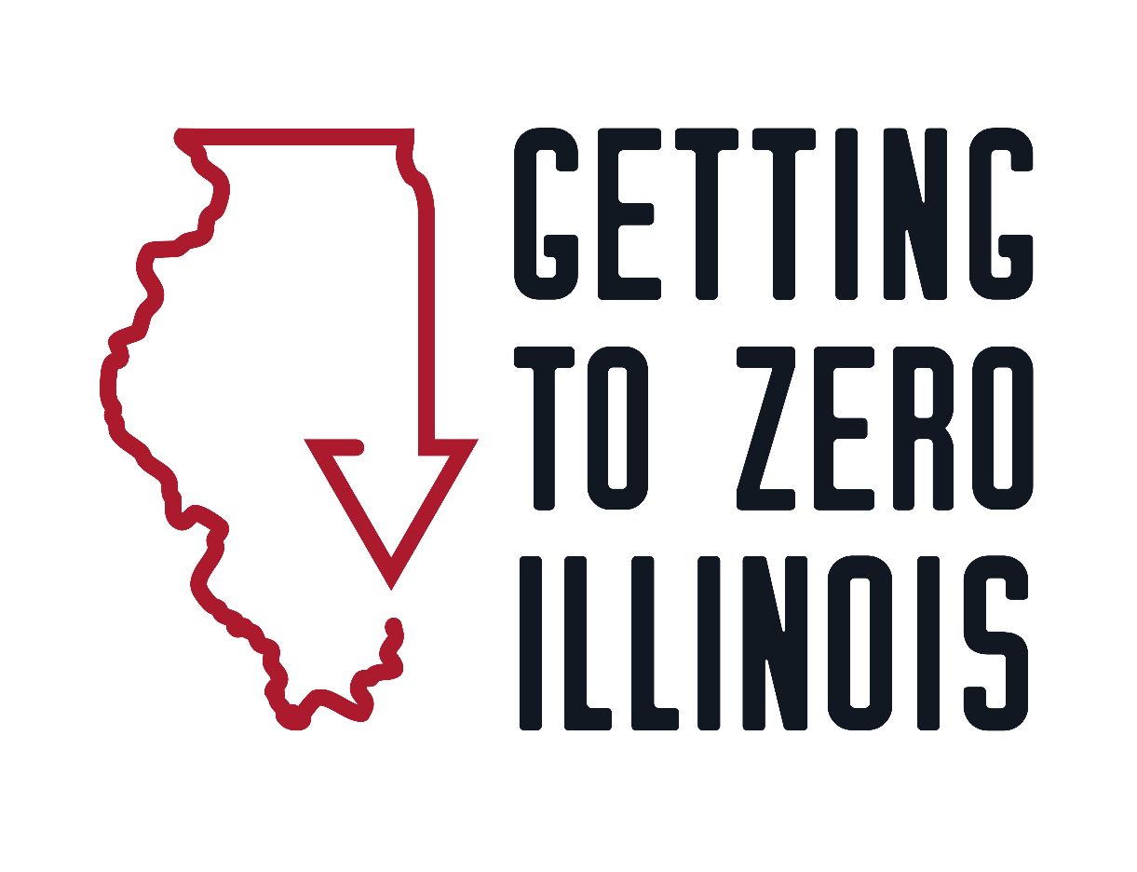

GETTING TO ZERO ILLINOIS COMMUNITY GRANT
REQUEST FOR PROPOSALS
APPLICATION FORM
MARCH 2021

Table of Contents
Organization Information 3
Narrative Application 7
Budget Template 9
Workplan Template 10
Organizational Leadership Approval 11
Remaining attachments list and submission instructions 12

Organization Information

Organization Information
Organization’s Legal Name:
Organization’s Tax ID #:
Organization’s Mailing Address:
Street: City/town: ZIP:
Organization’s Phone:
Organizational Website:
Application Contact Person: Contact Person’s pronouns:
Contact Person’s Email address:
Type of Organization:
☐ Not-for-Profit Organization
☐ Health department or other government agency
☐ Medical/Health Care Provider
☐ Other (Please specify: ________________)

Does your organization have 501(c)(3) not-for-profit status?
Please list the fiscal agent for this application and grant program (could be applicant or another organization):
Tax ID Number (EIN):
Overall Agency Budget:

Proposed Project/Program Information
Proposed Project/Program Name:
Amount of Request:
Selected Funding Category (Categories and descriptions are found on pages 6-8 of the Instructions and Guidance document):
☐ Category I: Community Mobilization and Advocacy
☐ Category II: Education and Training
☐ Category III: Programming and Services

- Population of focus for the proposed project/program. Please check all that apply. Highlighted groups at the top of the chart are GTZ-IL’s priority populations.
☐Black gay and bisexual men, and other men who have sex with men | ☐Latino/x gay and bisexual men, and other men who have sex with men
☐Black transgender women | ☐Black cisgender women
☐Native American/Indigenous people | ☐Asian/Pacific Islander people
☐Youth | ☐Older adults
☐Transgender people | ☐Gender nonconforming/nonbinary people
☐People living with HIV | ☐People who are not living with HIV
☐People who inject drugs | ☐People who use substances
☐People experiencing housing insecurity or homelessness | ☐People who are undocumented
☐People involved with the criminal justice system | ☐Other (please specify here)

1a. If your population(s) of focus include groups beyond GTZ-IL’s priority populations (highlighted in
gray in the table above), please outline the evidence of need and/or elevated HIV vulnerability:
- Please indicate which region(s) will be served by your grant request (find Illinois care/prevention regions here: https://hivcareconnect.com/hiv-care-connect-regions):
☐Region 1
☐Region 2
☐Region 3
☐Region 4
☐Region 5
☐Region 6
☐Region 7
☐Region 8

- Please provide the demographic breakdown of your clients, board of directors, and staff using the charts below. If these charts do not reflect how you collect or report this data, please feel free to include additional files and attach them to your application.
Client Race/Ethnicity | # | % | Board Race/Ethnicity | # | % | Staff Race/Ethnicity | # | %
White |  |  | White |  |  | White
Black/African American |  |  | Black/African American |  |  | Black/African American
Latino/Latinx |  |  | Latino/Latinx |  |  | Latino/Latinx
Asian/Pacific Islander |  |  | Asian/Pacific Islander |  |  | Asian/Pacific Islander
Native American/ Indigenous |  |  | Native American/ Indigenous |  |  | Native American/ Indigenous
Other (please specify) |  |  | Other (please specify) |  |  | Other (please specify)
Other (please specify) |  |  | Other (please specify) |  |  | Other (please specify)

Client Gender | # | % | Board Gender | # | % | Staff Gender | # | %
Cisgender Male |  |  | Cisgender Male |  |  | Cisgender Male
Cisgender Female |  |  | Cisgender Female |  |  | Cisgender Female
Transgender Male |  |  | Transgender Male |  |  | Transgender Male
Transgender Female |  |  | Transgender Female |  |  | Transgender Female
Nonbinary/  Nonconforming |  |  | Nonbinary/  Nonconforming |  |  | Nonbinary/  Nonconforming

4. Do you consider your organization to be Black- or Latino/x-led? If so, please explain why.

5. Please list the agency’s five largest private funding sources. Please include the amounts contributed during the current fiscal year. (Private funding includes foundations, corporations, events and/or individuals.) Do not list city, state and federal grants here.

Funder | Amount Contributed
6. Please list your agency’s total revenue for the current fiscal year and previous fiscal year.

 | Current Fiscal year | Previous Fiscal year
Corporate revenue
Foundation revenue
Event revenue
Individual contributions

Narrative Application

Agency Information (20 points total)
- Agency/Organization Mission Statement (up to 3 sentences) (5 points)

- Please describe a brief history of your organization, and please include information about your HIV and AIDS prevention, care and/or advocacy strategies. (400 words maximum) (10 points)

- Please describe how you and your staff are or have been involved in the Getting to Zero Illinois initiative and/or other local, regional, and/or national coalitions, committees or organizations that work to address and end the HIV epidemic in Illinois. (300 words maximum) (5 points)

Project Proposal Information (80 points total)
- Describe the project need and justification. (200 words maximum) (10 points)

- Describe the project design and characteristics. (400 words maximum) (10 points)

- Which Getting to Zero Illinois goal(s) and/or strategy(ies) does your project align with and advance? (200 words maximum) (see Appendix A for a list of GTZ-IL goals and strategies) (5 points)

- Which Getting to Zero Illinois Guiding Principle(s) does your project align with and advance? In what ways? (200 words maximum) (see Appendix B for a list of GTZ-IL Guiding Principles) (5 points)

- How does your project involve and prioritize people living with and/or vulnerable to HIV? (300 words maximum) (15 points)

- How does your project involve and prioritize GTZ-IL’s key populations, which are listed below? (300 words maximum) (15 points)

- Black gay and bisexual men and other men who have sex with men
- Latino/x gay and bisexual men and other men who have sex with men
- Black transgender women
- Black cisgender women
Note: Applicants may cite epidemiological evidence in proposing strategies to serve other target populations. Getting to Zero Illinois recognizes that characteristics such as age, income, gender, immigration status, nationality, drug use, mental health, incarceration and/or other factors elevate HIV vulnerability among certain groups.
- How does the proposed project leverage your organization’s existing partnerships and programs? (200 words maximum) (10 points)
- List other revenue awarded, raised, or requested to support the project proposed in this application. (0 points)
Funder | Amount | Status (requested/awarded)

- Program/project evaluation (300 words maximum) (10 points total)
  - What does success look like for your proposed project/program?
  - Are you aiming to achieve process, output or impact objectives? Please describe them.
Process Objective: A specific, short-term activity.
Example: By October 2021, staff will conduct four focus groups with at least 50 Black and Latinx youth to gather qualitative information and input on social media campaign messaging.
Outcome Objective: A focused, expected short-term intended result of your intervention based on a measured change by the priority population. Often, several outcome objectives cumulatively should result in the achievement of an impact objective.
Example: By May 2022, at least 200 Black and Latinx youth who saw the social media campaign in our county will report an increase in their intention to use condoms.
Impact Objective: A focused and reasonable statement about the desired long-term impact of your program. The "who" is almost always the priority population. Impact objectives are usually quite broad.
Example: By the year 2023, the overall gonorrhea incidence rate for 15 to 24-year-old Black youth in our county will decrease from 1150 to 800.
  - What methods or tools will be used to track project objectives?
  - What types of information will be collected?

Budget Template

Getting to Zero Illinois Program Budget
Please use the budget template below to show your program’s expenses. Please provide a description, total amount, and portion of the total that is being requested from GTZ-IL. Insert rows as necessary to list each staff position assigned to the program. You may also insert rows for additional expenses as needed. Please use the description column to explain the expense. For example:
EXPENSES
 | Description | Program Amount | Amount Requested from GTZ-IL
Materials/Supplies | 50 folding chairs x $10 each | $500 | $300

PROGRAM EXPENSES
 | Description | Total  Program Amount | Amount Requested from GTZ-IL
Staff Salaries
(insert rows to list individual staff positions and their time of the project)
(Position Title)
(Position Title)
Fringe Benefits
Consultant Fees
Rent/Utilities
Staff Training
Conferences/Meetings
Telephone/Fax/Internet
Equipment
Postage/Delivery
Travel
Printing/Copying
Materials/Supplies
Other Expenses
(insert other lines as necessary)
Total Expenses |  | $ | $

Workplan Template

Getting to Zero Illinois 2021-2022 Work Plan

Please use this form to describe your program’s goal, objectives and key activities. If possible, include staff responsible and expected completion date for each objective. Please add additional tables if you have more than one objective and use the rows you need to support your goal (add or delete as relevant).

Goal:

Objective 1:
Activities |  |  | Staff Responsible | Projected Completion Date
 | Please list staff person who will oversee program evaluation and that GTZ can contact to discuss project/program data and success measures
Objective 2 (if applicable):

Activities |  |  | Staff Responsible | Projected Completion Date

Organizational Leadership Approval

This application for funds has been reviewed and approved by:

____________________________________________
Printed Name

_____________________________________________ _______________________
Signature Date

Submit applications to ssemelka@aidschicago.org by Monday, April 26, 2021 by 5 p.m. with “Getting to Zero RFP Submission” as the subject line.
If you have questions, please contact:
Sara Semelka, Senior Program Manager
AIDS Foundation Chicago | Getting to Zero Illinois
ssemelka@aidschicago.org
No application received after 5 p.m. on Monday, April 26, 2021 will be accepted.

Remaining attachments list and submission instructions

Please make sure you have filled out the portions of the packet in their entirety:
- Organization information form
- Narrative Application
- Budget template
- Workplan template
Below is a reminder of the remaining materials needed to complete a full application, how to format and submit a full application.
Proposals must be submitted electronically to ssemelka@aidschicago.org by Monday, April 26, 2021 at 5 p.m. Subject line of the email should read: Getting to Zero RFP Submission.
In addition to this application packet, submissions need to contain the following items:
- The applicant agency’s IRS 501(c) (3) designation notification letter
- The agency’s most recent audited financial statements
- The agency’s most recent operating budget
- Proof of insurance
- List of board members, including affiliations
- If applying as a collaborative or a partnership, include a Memoranda of Understanding
Formatting of submitted items
Refer to the chart below for the document formatting requirements. GTZ-IL has outlined these so that all applications will look uniform and be evaluated on content alone.

Item | Type of Document | File name format
GTZ-IL Application Form | Word Document | AgencyName_GTZ_RFP_Application.doc
The applicant agency’s IRS 501(c) (3) designation notification letter | PDF | AgencyName_501c3_letter.pdf
The agency’s most recent audited financial statements | PDF | AgencyName_financials.pdf
The agency’s most recent operating budget | PDF | AgencyName_operating_budget.pdf
Proof of insurance | PDF | AgencyName_insurance.pdf
List of board members, including affiliations | PDF | AgencyName_board_list.pdf
Memoranda of Understanding (if applicable) | PDF | AgencyName_MOU.pdf

